Submission to the Office of the United Nations High Commissioner for Human Rights

Call for Input: Environmental human rights defenders and the human right to a clean, healthy and sustainable environment

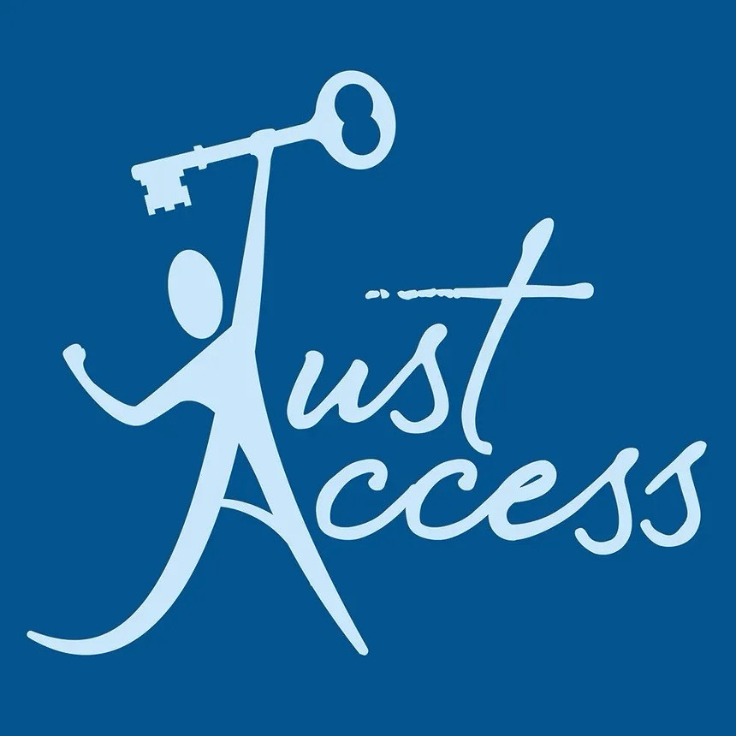

Submitting organisation: Just Access e.V. (Germany)

Contact: contact@just-access.de – www.just-access.de

Date: August 2026

Publication: Just Access consents to the publication of this submission on the OHCHR website.

Executive summary
Protection of environmental human rights defenders (EHRDs) means little if it does not extend to the courtroom. EHRDs in Germany face legal, financial, and reputational pressure not because the State lacks formal recognition of their role, but because the legal and practical infrastructure meant to protect them remains incomplete.

The clearest illustration of this gap is Germany’s failure to transpose Directive (EU) 2024/1069 by the May 2026 deadline, leaving EHRDs exposed to defamation-based SLAPPs. This is not a marginal compliance lapse, since SLAPPs are one of the most prominent and fastest-growing forms of interference through which EHRDs in developed countries are silenced. The absence of a functioning anti-SLAPP framework intensifies the financial vulnerability of small NGOs and thereby leads to self-censorship. Political stigmatisation of EHRDs as “extremists” and rising online abuse leave EHRDs unable to carry out this urgently necessary environmental work safely.

Just Access focuses on the specific risks SLAPPs pose to EHRDs in Germany, the structural factors worsening their situation, and the concrete legislative and institutional measures needed to protect them. This submission aims to address subsection one and selected elements of subsection two of the call for input, given our institutional expertise.

- Introduction
Just Access e.V. is a human rights non-governmental organisation based in Germany, working in the field of access to justice and international law. Our work spans strategic litigation before international courts, legal research, and engagement with United Nations human rights mechanisms, with areas of focus including state responsibility, business and human rights, environmental justice, and institutional accountability. We engage regularly with UN treaty bodies and special procedures to advance the implementation of human rights standards in domestic legal orders.

Consistent with that expertise, this present submission provides input on the current situation of Environmental Human Rights Defenders (EHRDs) in Germany. It responds to the Special Rapporteur’s call for input on EHRDs and the human right to a clean, healthy and sustainable environment.

Just Access e.V. considers itself an EHRD, consistent with the United Nations’ understanding of the term as encompassing any individual or group who, individually or in association with others, works peacefully to protect and promote human rights relating to the environment. This self-understanding is reflected across the organisation’s activities. Just Access has directly engaged with UN human rights mechanisms on climate-related issues, including through a submission to four UN Special Rapporteurs focusing on children’s climate rights in Germany submitted in 2025.

Beyond formal submissions, the organisation regularly publishes blog posts and podcasts examining developments in climate change law and analysing recent court rulings. Just Access has further extended its engagement to the intersection of climate change and food insecurity, including through its participation in the Dublin City University (DCU) meeting on food security and global diplomacy.

- Specific Risks faced by Environmental Human Rights Defenders
Even though EHRDs in Germany are less likely to face physical danger or repression than they do in less developed countries, this does not preclude them from experiencing impediments to their work. The most common and increasingly prevalent form of interference faced by EHRDs in developed countries is the exposure to strategic lawsuits against public participation (SLAPPs), a mechanism already recognised within the UN system as contributing to the closing of civic space.
A prominent example in Germany is the SLAPP brought by Kenertec (a company identifying as part of the Korindo Group) against Rainforest Rescue before the Regional Court in Hamburg (2019-2023). In this instance, the Indonesian company Kenertec demanded that Rainforest Rescue revoke its statements on the use of bulldozers and fire in connection with clearing the rainforest in Papua province. Rainforest Rescue refused, and although the claims were ultimately dropped in 2023 after three years of proceedings, the organisation reported that litigation had drained its capacities and was intended to intimidate them.

This illustrates how the underlying power imbalance between EHRDs and corporate or state actors allows SLAPPs to succeed in their coercive purpose even where the claim itself fails on the merits. SLAPPs are typically initiated against EHRDs who speak out against powerful corporate actors or State authorities, request access to information, participate in peaceful protest, or bring legal challenges. Such proceedings are pursued through civil, criminal and administrative channels, most commonly through defamation claims. Frequently, multiple proceedings are initiated at the same time, placing not only a financial but also psychological burden on those targeted.

Criminal proceedings expose environmental defenders to particularly severe risks, ranging from substantial fines to potential imprisonment, while non-criminal proceedings often involve disproportionate claims for damages or sanctions, as well as far-reaching demands for removal of content and reports. Additionally, plaintiffs compound this pressure through legal intimidation tactics, including threats of further proceedings and the strategic use of delay, aimed at psychologically pressuring EHRDs to drop their work against misconduct. The consequences of this exposure are severe, as the high legal costs associated with SLAPPs are especially devastating for small NGOs and individuals with limited financial resources, fostering a climate of fear that leads EHRDs to abandon important campaigns simply to avoid the risk of ruinous litigation.

In Germany, this problem is further complicated by the incomplete transposition of Directive (EU) 2024/1069 on protecting persons who engage in public participation from manifestly unfounded claims or abusive court proceedings. Germany missed the 7 May 2026 transposition deadline. The government’s implementing bill, adopted by the Federal Cabinet on 10 December 2025, is before the Bundestag but not yet in force. As drafted, it limits protection to cross-border matters and excludes purely domestic proceedings, which, given that only 8.5 percent of European SLAPPs are cross-border, would leave the overwhelming majority of SLAPP targets in Germany unprotected. Due to the failure to transpose Directive (EU) 2024/1069 in time, Germany, along with thirteen other EU countries, currently faces infringement proceedings initiated by the European Commission on 15 July 2026.

Small NGOs acting as EHRDs also struggle to secure sufficient and reliable funding to sustain their work. As a result, the cost exposure of litigation frequently becomes a barrier to accountability, since the resources to bring a case are simply not there.

The work of EHRDs is further complicated by the insufficient collection of data. For example, in order to inform submissions to multiple UN Special Rapporteurs, Just Access e.V. submitted a Freedom of Information request to Baden-Württemberg’s education ministry seeking data on school closures caused by heat. However, no such data is collected, illustrating how environmental advocacy is obstructed by a lack of reliable underlying data.

- Impacts on EHRDs
These risks translate into high costs and significant resource diversion. EHRDs are forced to defend themselves against fabricated or exaggerated claims, incurring substantial legal and court fees in the process. Aside from the financial burden, EHRDs must also dedicate a considerable amount of time on SLAPP proceedings, further straining their already limited resources and diverting capacity away from environmental work. These consequences disproportionately affect small, local groups and NGOs, as they typically operate with a small number of staff and limited resources to begin with.
Beyond the financial and organisational burdens, exposure to SLAPPs carries a significant psychological impact, particularly for small NGOs like Just Access. As small organisations oftentimes only operate with a handful of staff, the prospect of lengthy litigation can produce heightened stress and risk of burnout, as the same limited staff must simultaneously sustain their environmental work and manage legal defence. To avoid these consequences, EHRDs often resort to self-censorship, refraining from speaking out or retracting true reports. This, in turn, inhibits public debate on climate change and environmental harm, limiting the potential impact of EHRDs. For small NGOs such as Just Access, this internalised self-censorship risks undermining not only individual campaigns but the organisation’s broader capacity to fulfil its mission over time.
From a legal perspective, current practices targeting EHRDs endanger the rights to freedom of expression, assembly, association and the right to public participation, as enshrined in Articles 19 to 21 of the Universal Declaration of Human Rights (UDHR), as well as Articles 19, 21, 22 and 25 of the International Covenant on Civil and Political Rights (ICCPR). These practices furthermore infringe the Aarhus Convention, to which Germany is a party, which protects the rights to information, participation, and access to justice in environmental matters. One of its central provisions of this framework is Article 3 (8), which requires Parties to ensure that persons exercising their rights under the Convention are not penalised, persecuted, or harassed. This creates a legal obligation directly prohibiting SLAPPs and other forms of abusive practices. However, as demonstrated above, all of the core rights provided for in the Aarhus Convention are currently impeded in some form. For example, access to information is obstructed by insufficient collection of environmental data by authorities, while access to justice is undermined by the above-mentioned cost-barriers, despite Article 9 (4) of the Aarhus Convention specifically requiring that environmental justice procedures not be “prohibitively expensive”. Public participation is often inhibited by the self-censorship EHRDs adopt in the attempt to avoid these very consequences.

- Factors contributing to the worsening situation of EHRDs
The already critical situation is further intensified by the stigmatisation of EHRDs, a shifting focus in political debate, and an increased occurrence of online abuse. These pressures have a particularly hard impact on small NGOs which engage as EHRDs such as Just Access. As political attention shifts away from climate policies and civil society protection toward economic concerns, inflation, and migration, EHRDs are increasingly stigmatised as “extremists”. For small, resource-constrained organisations, this label carries particular weight because it reframes legitimate advocacy as a threat to the public order, which in turn undermines public solidarity with EHRDs and diminishes the societal support their work depends on. As a result, small EHRDs face not only legal and financial pressure but also a weakening of public support that has in the past shielded civil society actors from severe forms of repression.
Additionally, this vulnerability of EHRDs is compounded by increasing online abuse, including phishing attempts, coordinated cyberbullying, doxxing, and hate speech across social media platforms. For organisations with limited staff, responding to such abuse draws directly on the same limited capacity needed for substantive environmental work. This further impedes their work and reinforces stigmatisation, creating a compounding effect in which reputational attacks and digital harassment reinforce one another. As a result, small NGOs such as Just Access are disproportionately exposed on multiple fronts at once.

- Policies, regulations and practices adopted to protect EHRDs
As already correctly identified in the OHCHR report on “The impact of SLAPPs on human rights and how to respond”, one of the most important steps States must take is the adoption of adequate anti-SLAPPs legislation to ensure the timely dismissal of unfounded claims. Furthermore, it is essential to raise awareness for both the use of SLAPPs and the online abuse EHRDs are confronted with. It is important to train judges, prosecutors and lawyers to correctly and swiftly identify these tactics, in order to protect EHRDs effectively.

- Recommendations
Just Access respectfully submits the following recommendations for the Special Rapporteur’s consideration:

- The Special Rapporteur should urge States already bound by Directive (EU) 2024/1069, including Germany, to implement adequate anti-SLAPP legislation without further delay and to ensure that it provides for early dismissal of manifestly unfounded claims.
- The Special Rapporteur should call on States to adopt dedicated anti-SLAPP legislation where none exists, consistent with the OHCHR’s own findings on SLAPPs, including mechanisms for early judicial screening to deter abusive claims and protect against parallel or repeated proceedings.
- The Special Rapporteur should recommend mandatory training for judges, prosecutors, and lawyers to recognise SLAPP tactics and online abuse targeting EHRDs, so these can be identified and addressed swiftly.
- The Special Rapporteur should call on States to improve data collection by public authorities on climate-related impacts, so that environmental advocacy is not obstructed by the absence of an evidentiary basis needed to hold States accountable.
- The Special Rapporteur should recommend sustainable funding mechanisms for civil society and NGOs engaged in environmental human rights work, to reduce the financial burden that makes SLAPPs an effective silencing tool against small organisations.
- The Special Rapporteur should urge States to publicly and consistently affirm the legitimacy of the work of EHRDs, countering political stigmatisation that frames environmental advocacy as extremism and that erodes the public support EHRDs rely on for protection.
- The Special Rapporteur should urge States to require social media platforms to implement regulatory measures against coordinated online abuse, such as doxxing, phishing, and harassment targeting EHRDs, since digital abuse and reputational attacks reinforce each other.

Just Access e.V. remains available to provide further information or to engage in dialogue with the Special Rapporteur’s office. We thank the Special Rapporteur for the opportunity to contribute to this important thematic report.

UN Environment Programme, Environmental defenders (2026), https://www.unep.org/topics/environmental-law-and-governance/promoting-environmental-rule-law/environmental-defenders (last visited July 23, 2026); United Nations Office of the High Commissioner for Human Rights, Declaration on Human Rights Defenders, https://www.ohchr.org/en/special-procedures/sr-human-rights-defenders/declaration-human-rights-defenders (last visited July 23, 2026).
See Global Witness, Roots of Resistance (17 September 2025), https://globalwitness.org/en/campaigns/land-and-environmental-defenders/roots-of-resistance/ (last visited 23 July 2026); Michel Forst, Report on key trends and threats regarding environmental defenders, UN Special Rapporteur on Environmental Defenders under the Aarhus Convention (September 2025), https://unece.org/sites/default/files/2025-10/Aarhus_SR_EnvDef_MOP8_Report_Key_Trends_and_Threats_ENG.pdf (last visited 23 July 2026).
European Parliament, The Use of SLAPPs to Silence Journalists, NGOs and Civil Society, https://www.europarl.europa.eu/RegData/etudes/STUD/2021/694782/IPOL_STU%282021%29694782_EN.pdf (last visited July 23, 2026).
Rainforest Rescue, SLAPP lawsuit against Rainforest Rescue struck down (21 February, 2023), https://www.rainforest-rescue.org/updates/11244/slapp-lawsuit-against-rainforest-rescue-struck-down (last visited July 23, 2026).
Michel Forst, Report on key trends and threats regarding environmental defenders, UN Special Rapporteur on Environmental Defenders under the Aarhus Convention (September 2025), https://unece.org/sites/default/files/2025-10/Aarhus_SR_EnvDef_MOP8_Report_Key_Trends_and_Threats_ENG.pdf (last visited July 23, 2026).
EAPIL, Status of the Anti-SLAPP Directive Transpositions at the 7 May 2026 Deadline (7 May 2026), https://eapil.org/2026/05/07/status-of-the-anti-slapp-directive-transpositions-at-the-7-may-2026-deadline/ (last visited July 23, 2026).
Bundesrechtsanwaltskammer, Regierung beschließt Entwurf zum Schutz vor SLAPP-Klagen (17 December 2025), https://www.brak.de/newsroom/news/einschuechterungsklagen-regierung-beschliesst-entwurf-zum-schutz-vor-slapp-klagen/ (last visited July 23, 2026); Coalition against SLAPPs in Europe, 2025 Report: SLAPPs in Europe – Democracy in the Dock (28 January 2026), https://www.the-case.eu/resources/2025-report-slapps-in-europe-democracy-in-the-dock/ (last visited July 23, 2026).
Business and Human Rights Centre, EU: European Commission takes action against member States for failing to implement Anti-SLAPP Directive on time (16 July 2026), https://www.business-humanrights.org/de/neuste-meldungen/eu-european-commission-takes-action-against-member-states-for-failing-to-implement-anti-slapp-directive-on-time/ (last visited July 23, 2026).
See Aarhus Convention (30 October 2001), https://unece.org/environment-policy/public-participation/aarhus-convention/text (last visited July 23, 2026).
OHCHR, The impact of SLAPPs on human rights and how to respond (29 April 2024), https://www.ohchr.org/en/documents/brochures-and-leaflets/impact-slapps-human-rights-and-how-respond (last visited July 23, 2026)

