Contribution of Just Access e.V.

Committee on the Rights of Persons with Disabilities - Call for Inputs

Two Draft General Comments on Article 11 of the Convention (Situations of risk, including humanitarian emergencies)

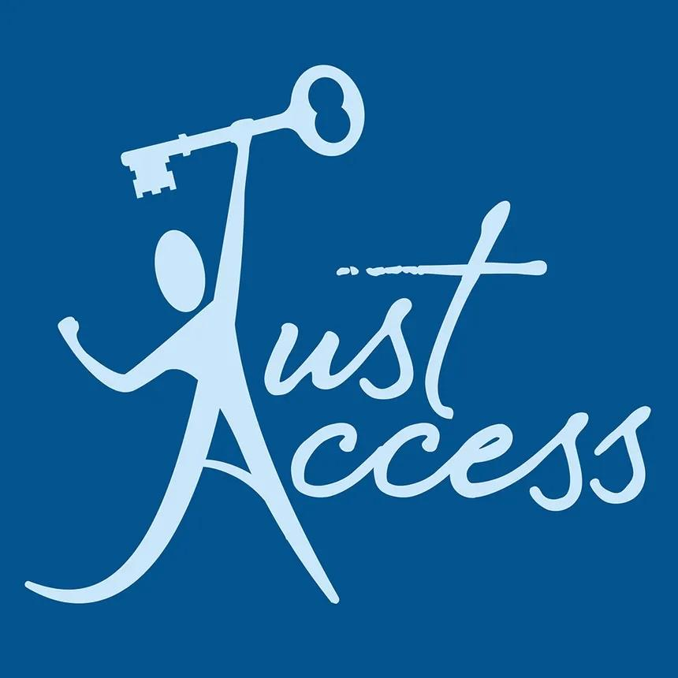

Organization: Just Access e.V. (registered non-profit human rights association, Germany)
Just Access e.V. is an independent human rights organisation specialising in public international law and access to justice. We provide pro bono legal assistance and representation to victims of human rights violations before international, regional and domestic bodies, and we pursue strategic litigation, legal research and training aimed at securing effective remedies and structural change for people and communities in vulnerable circumstances. Consistent with this mandate, our contribution concentrates on a cross-cutting dimension of Article 11: the right of persons with disabilities to access to justice, effective remedies, reparation and accountability when protection fails in situations of risk.

Part A - Draft General Comment No. 9 (obligation of States parties in situations of risk)

Comment / proposal to paragraph 2
Proposal - insert a new sentence at the end of the paragraph:

“This underutilization is especially pronounced in the accountability and remedial dimension of protection: violations committed against persons with disabilities in situations of risk are rarely identified, investigated, prosecuted or remedied. The Committee recalls that the Security Council, in its first-ever resolution on persons with disabilities in armed conflict, resolution 2475 (2019), called upon States to end impunity for crimes against persons with disabilities and to ensure their access to justice, effective remedies and, as appropriate, reparation.”

Rationale. Anchoring the “underutilization” finding to the accountability gap frames Article 11 as a source of remedial as well as preventive obligations, and situates the general comment within an emerging cross-institutional consensus. Security Council resolution 2475 (2019) (the first stand-alone resolution on the protection of persons with disabilities in conflict) expressly links protection to ending impunity and to access to justice, effective remedies and reparation. The persistence of an “accountability void” for crimes against persons with disabilities is documented in the international legal literature.

Comment / proposal to paragraph 42
Proposal - replace “appropriate remedies, reparations, and redress” and add a following sentence:
“…the obligation to fulfill requires States parties to promote, facilitate, and provide an effective remedy and full and adequate reparation for violations specifically targeting or impacting persons with disabilities in situations of armed conflict. Reparation should be disability-inclusive and accessible and comprise, as appropriate, the five established forms of restitution, compensation, rehabilitation, satisfaction and guarantees of non-repetition, in line with the Basic Principles and Guidelines on the Right to a Remedy and Reparation for Victims of Gross Violations of International Human Rights Law and Serious Violations of International Humanitarian Law. Rehabilitation under articles 25 and 26 of the Convention and guarantees of non-repetition are of particular importance for persons with disabilities.”

Rationale. The zero-draft refers to “remedies, reparations, and redress” without anchoring the applicable standard or specifying what reparation entails. The Basic Principles and Guidelines (General Assembly resolution 60/147, 2005) provide the authoritative articulation of the right to a remedy and identify the five forms of reparation. Read together with articles 13 and 26 of the Convention, they give the obligation to fulfil concrete and disability-specific content.

Comment / proposal to paragraph 43
Proposal - add two sentences at the end of the paragraph:
“Effective accountability further requires that States parties collect disaggregated data on violations affecting persons with disabilities, in accordance with article 31 of the Convention, and ensure the inclusion and effective participation of victims with disabilities in investigative, fact-finding and monitoring processes. Persons with disabilities have too often been rendered invisible in the work of international, hybrid and domestic tribunals, which have consistently failed to record, investigate and prosecute crimes committed against them.”

Rationale. Documentation is a precondition of accountability: where victims with disabilities are not counted, crimes against them are not prosecuted. The under-representation of persons with disabilities across international, hybrid and domestic accountability mechanisms (and the practical steps to close it through inclusive fact-finding and investigation) are well documented.

Comment / proposal - new recommendation after paragraph 71
Proposal - add a new recommendation:
“States parties should guarantee access to justice, effective remedies and full reparation for persons with disabilities harmed in situations of risk, including by removing procedural barriers, providing procedural and age- and gender-appropriate accommodations, and ensuring the participation of persons with disabilities and their representative organizations in accountability, fact-finding and transitional-justice mechanisms. States parties and other actors engaged in the progressive development of international law should further ensure that the rights of persons with disabilities (such as their right to a remedy and reparation) are expressly integrated into instruments bearing upon protection, such as the process launched by General Assembly resolution 79/122 (2024) towards a convention on the prevention and punishment of crimes against humanity.”

Rationale. A dedicated recommendation on remedies and accountability would complement the draft’s strong preventive and protective recommendations. The reference to the crimes against humanity process is forward-looking: that process is now under way on the basis of the International Law Commission’s 2019 Draft Articles and offers a concrete opportunity to embed a disability perspective in general international law. Detailed guidance on inclusive access to justice already exists in the International Principles and Guidelines on Access to Justice for Persons with Disabilities (2020).

Part B - Draft General Comment No. 10 (addressing the impact of situations of risk)

Comment / proposal to paragraph 49
We welcome this section and propose that its list of recommended measures be strengthened by adding the following sub-paragraphs:
“(–) Recognize that the right to an effective remedy is immediately applicable and non-derogable, and applies in all situations of risk, and ensure that remedies are, in law and in practice, accessible to persons with disabilities on an equal basis with others, drawing on the Basic Principles and Guidelines on the Right to a Remedy and Reparation and on the International Principles and Guidelines on Access to Justice for Persons with Disabilities;
(–) Ensure full reparation comprising, as appropriate, restitution, compensation, rehabilitation, satisfaction and guarantees of non-repetition, provided in accessible form, and treat rehabilitation and guarantees of non-repetition as structural remedies directed at dismantling the barriers that generated the harm, rather than as individual measures alone, and ensure, as a measure of satisfaction, that accurate accounts of violations committed against persons with disabilities are included in international humanitarian law and human rights training and in educational materials for military, humanitarian and emergency personnel;
(–) Ensure that structural remedies, including guarantees of non-repetition, are effectively resourced, and recognize that a State party may not invoke a lack of financial resources to justify a failure to protect persons with disabilities in situations of risk. States parties should mobilize the maximum available resources before contemplating any measure that reduces the level of protection. Any deliberately retrogressive measure affecting the protection of persons with disabilities in situations of risk is presumptively impermissible, and the burden rests on the State party to demonstrate that it was adopted after the most careful consideration of all alternatives, that it is duly justified by reference to the totality of the rights provided for in the Convention and in the context of the full use of the State party’s maximum available resources, and that it does not have a disproportionate impact on persons with disabilities;
(–) Remove procedural barriers that disproportionately affect persons with disabilities, including by removing financial barriers such as court fees and the risk of adverse costs, and by ensuring that statutes of limitation do not bar claims arising from gross violations that constitute crimes under international law, and by suspending or extending limitation periods where institutionalization, denial of legal capacity or inaccessibility prevented a person with a disability from bringing a timely claim;
(–) Guarantee free legal assistance to persons with disabilities who cannot otherwise afford it, and ensure access to support services for victims and witnesses with disabilities throughout justice and accountability processes;
(–) Ensure access to an effective remedy where business enterprises or other private actors — such as private providers of institutional care, transport, shelter or humanitarian services — cause or contribute to protection failures in situations of risk, consistent with the third pillar (access to remedy) of the United Nations Guiding Principles on Business and Human Rights;
(–) Provide for collective and representative remedies, so that structural failures of protection affecting persons with disabilities may be addressed beyond the individual case, complementing the individual communications and inquiry procedures under the Optional Protocol to the Convention.”

Rationale. The existing section addresses many procedural aspects of access to justice. These additions supply the substantive architecture of the remedy, namely its legal basis and non-derogability, the content of reparation, the treatment of limitation periods, the position of private actors, and the availability of structural remedies. They reflect Just Access’s practice, in which effective remedies for individuals are used to secure structural change for all those similarly situated. Failures of protection in situations of risk are frequently attributed to resource constraints, and accessible preparedness, evacuation, shelter and reconstruction measures are among the first to be reduced when budgets contract. A remedy that a State party declines to fund is not an effective remedy. Guarantees of non-repetition, which are central to Article 11, are illusory unless the resources required to give effect to them are mobilized. The proposed text applies to situations of risk the standard the Committee has already articulated in general comment No. 8, under which retrogressive measures are impermissible and the burden of justification rests on the State party. It also reflects the guidance of the United Nations High Commissioner for Human Rights that States should dedicate the maximum available resources to the realization of the rights of persons with disabilities. Read together with the redistributive dimension of inclusive equality recognized in general comment No. 6, this confirms that resource allocation is a matter of legal obligation under the Convention.

Editorial note. Footnote 14 of the zero-draft cites the International Principles and Guidelines on Access to Justice for Persons with Disabilities as “2016”. These Principles were issued on 28 August 2020; we recommend correcting the citation.

Comment / proposal to paragraph 49, sub-paragraph beginning “Recognize the Nuremberg legacy…”
Proposal - revise the sub-paragraph to read:
“Recognize the Nuremberg legacy according to which international crimes perpetrated against persons with disabilities were deemed to be crimes against humanity, and ensure that the rights, participation and reparation of victims with disabilities are expressly reflected in the ongoing elaboration of a convention on the prevention and punishment of crimes against humanity pursuant to General Assembly resolution 79/122 (2024) and the International Law Commission’s Draft Articles.”

Rationale. The draft already invokes the Nuremberg legacy. The proposed addition converts that historical reference into a present-day law-reform opportunity. Integrating a disability perspective into the crimes against humanity process would help close the accountability void at the level of general international law.

Comment / proposal to paragraph 50
Proposal - add a new sub-paragraph:
“(–) Extend data collection beyond needs and risks to encompass violations, harms and access to justice outcomes affecting persons with disabilities in situations of risk, so that impunity can be measured and progressively eliminated, such victim-related data being a precondition for effective remedy and accountability.”

Rationale. Article 31 data obligations are most often framed around identifying needs. Extending them to violations and remedy outcomes operationalises accountability and supports the access to justice measures proposed above.

Comment / proposal to paragraph 48
Proposal - add a new sub-paragraph:
“(–) Ensure that the independent monitoring frameworks designated under article 33(2), and the civil society and representative organizations of persons with disabilities involved under article 33(3), are empowered and resourced to monitor access to justice and remedy outcomes, to receive complaints of protection failures, and to support persons with disabilities in pursuing remedies.”

Rationale. Linking the monitoring architecture of article 33 to remedy outcomes ensures that accountability is measured, and reflects the role that national human rights institutions and civil society play in enabling access to justice.

Just Access e.V. thanks the Committee for the opportunity to contribute and remains available to provide further legal analysis in support of the two general comments.

See https://just-access.de/
UN Security Council resolution 2475 (2019), the first resolution on the protection of persons with disabilities in armed conflict; see UN, “Security Council Unanimously Adopts Resolution 2475 (2019)…”, 20 June 2019, https://press.un.org/en/2019/sc13851.doc.htm; UN DESA, https://www.un.org/development/desa/disabilities/news/dspd/un-security-council.html; resolution record, https://digitallibrary.un.org/record/3810148
W. I. Pons, J. E. Lord & M. A. Stein, “Addressing the Accountability Void: War Crimes Against Persons with Disabilities”, International Review of the Red Cross, No. 922 (2022), https://international-review.icrc.org/articles/addressing-the-accountability-void-war-crimes-against-persons-with-disabilities-922
Basic Principles and Guidelines on the Right to a Remedy and Reparation for Victims of Gross Violations of International Human Rights Law and Serious Violations of International Humanitarian Law, GA resolution 60/147 (16 Dec. 2005), esp. Principle 18 (forms of reparation), https://www.ohchr.org/en/instruments-mechanisms/instruments/basic-principles-and-guidelines-right-remedy-and-reparation
W. I. Pons, J. E. Lord & M. A. Stein, “Addressing the Accountability Void: War Crimes Against Persons with Disabilities”, International Review of the Red Cross, No. 922 (2022), https://international-review.icrc.org/articles/addressing-the-accountability-void-war-crimes-against-persons-with-disabilities-922; See the thematic issue “Persons with Disabilities in Armed Conflict”, International Review of the Red Cross, No. 922 (2022), including contributions on the practice of the international tribunals and on article 13 CRPD and the International Criminal Court, https://international-review.icrc.org/sites/default/files/reviews-pdf/2022-12/Persons-with-Disabilities-in-Armed-Conflict-International-Review-of-the-Red-Cross-b-No-922.pdf
UN General Assembly, Sixth Committee, “Crimes against humanity” (79th session), https://www.un.org/en/ga/sixth/79/cah.shtml; Human Rights Watch, “Moving Ahead to a Crimes Against Humanity Treaty”, 9 Jan. 2025, https://www.hrw.org/news/2025/01/09/moving-ahead-to-a-crimes-against-humanity-treaty
International Principles and Guidelines on Access to Justice for Persons with Disabilities (2020), https://www.ohchr.org/en/special-procedures/sr-disability/international-principles-and-guidelines-access-justice-persons-disabilities
Basic Principles and Guidelines on the Right to a Remedy and Reparation, GA resolution 60/147 (2005), including Section IV (statutes of limitations) and Principle 18 (reparation), and para. 22 (h) (satisfaction). https://www.ohchr.org/en/instruments-mechanisms/instruments/basic-principles-and-guidelines-right-remedy-and-reparation; International Principles and Guidelines on Access to Justice for Persons with Disabilities, issued 28 August 2020 by the Special Rapporteur on the rights of persons with disabilities, the Committee and the Special Envoy of the Secretary-General on Disability and Accessibility, https://www.ohchr.org/en/special-procedures/sr-disability/international-principles-and-guidelines-access-justice-persons-disabilities; UN Guiding Principles on Business and Human Rights (endorsed by Human Rights Council resolution 17/4, 2011), Pillar III (Access to Remedy), https://www.ohchr.org/en/publications/reference-publications/guiding-principles-business-and-human-rights; Convention on the Rights of Persons with Disabilities, art. 13, and Optional Protocol (individual communications and inquiry procedure), https://social.desa.un.org/issues/disability/crpd/convention-on-the-rights-of-persons-with-disabilities-crpd; Committee against Torture, general comment No. 3 (2012) on the implementation of article 14, CAT/C/GC/3, https://www.ohchr.org/en/documents/general-comments-and-recommendations/catcgc3-general-comment-no-3-2012-implementation
Committee on the Rights of Persons with Disabilities, general comment No. 8 (2022) on the right of persons with disabilities to work and employment, CRPD/C/GC/8, https://www.ohchr.org/en/documents/general-comments-and-recommendations/crpdcgc8-general-comment-no-8-2022-right-persons
Report of the United Nations High Commissioner for Human Rights on the right to work and persons with disabilities, A/HRC/46/47 (2021), prepared pursuant to Human Rights Council resolution 43/7, https://www.ohchr.org/en/documents/thematic-reports/ahrc4647-report-right-work-and-persons-disabilities
Committee on the Rights of Persons with Disabilities, general comment No. 6 (2018) on equality and non-discrimination, CRPD/C/GC/6, https://www.ohchr.org/en/documents/general-comments-and-recommendations/general-comment-no6-equality-and-non-discrimination
International Principles and Guidelines on Access to Justice for Persons with Disabilities, issued 28 August 2020 by the Special Rapporteur on the rights of persons with disabilities, the Committee and the Special Envoy of the Secretary-General on Disability and Accessibility, https://www.ohchr.org/en/special-procedures/sr-disability/international-principles-and-guidelines-access-justice-persons-disabilities
UN General Assembly, Sixth Committee, “Crimes against humanity” (79th session), https://www.un.org/en/ga/sixth/79/cah.shtml; on the disability dimension see Pons, Lord & Stein (2022), https://international-review.icrc.org/articles/addressing-the-accountability-void-war-crimes-against-persons-with-disabilities-922
Convention on the Rights of Persons with Disabilities, art. 31 (statistics and data collection), https://social.desa.un.org/issues/disability/crpd/convention-on-the-rights-of-persons-with-disabilities-crpd; W. I. Pons, J. E. Lord & M. A. Stein, “Addressing the Accountability Void” (2022), https://international-review.icrc.org/articles/addressing-the-accountability-void-war-crimes-against-persons-with-disabilities-922

